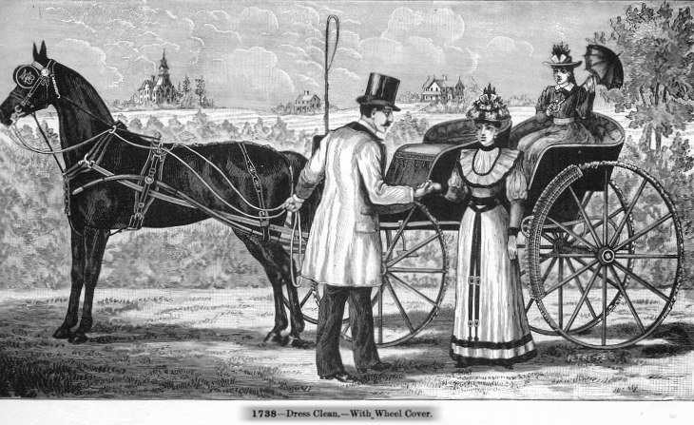
The Parked Horse with kicking strap and mud guard on the wheel
From: Moseman's Illustrated Catalog of Horse Furnishing Goods published in 1893.
The horse in this illustration has been asked to assume a "Parked" stance, making it less likely that it will move at the halt. It was important that the horse not take a step as the Lady dismounted from the carriage. Not only would her clothing be soiled, she could have been knocked to the ground which would have been a terrible social event for both her and her gentleman friend. Note the wicker wheel cover on the rear wheel used to protect her clothing.
Today's carriage drivers are taught to *always* be the first to mount and last to dismount from a vehicle so as to remain in the best position to control the horse(s). This driver is on the ground assisting his Lady friend and has left a passenger seated in the carriage, yet another reason to have the horse assume the "Parked" stance and be less likely to step forward. It is interesting that there was so much care taken to protect the Lady while mounting and dismounting yet the other lady passenger (perhaps she's even a child) has been left in a situation considered unsafe by today's standards.
Many of today's drivers assume the "Parked" stance is not traditional and should not be used by today's carriage horses, particularly by those in competitions. Carriage drivers will train their horses that have learned this "Parked" stance to never assume that position when asked to halt. The acceptability of the stance is more a matter of when it would be useful. Halting at X in a dressage test or standing in a line up in a carriage ring class in the "Parked" stance would not be appropriate since it is expected in those situations that the horse be capable of moving off in any direction immediately by instruction of the driver! It is a disobedience for the horse who knows how to stand in the "Parked" position to assume the stance without being instructed by the driver to do so. However, if a driver had a Lady passenger entering or exiting a vehicle, it might be quite appropriate - and traditional - to ask their horse(s) to stand in a "Parked" stance. This action is not seen with much frequency today in carriage driving because it is not called for in competition. Passengers and drivers are not usually called on to mount and dismount in a ring class or any of the other tests used in carriage competition.
Note the use of the kicking strap which is very ornately shaped and decorated by the harness maker!
©Jeff Morse ~ 2006

